**28/06/2017 – Comments from the customer**

**1.-**

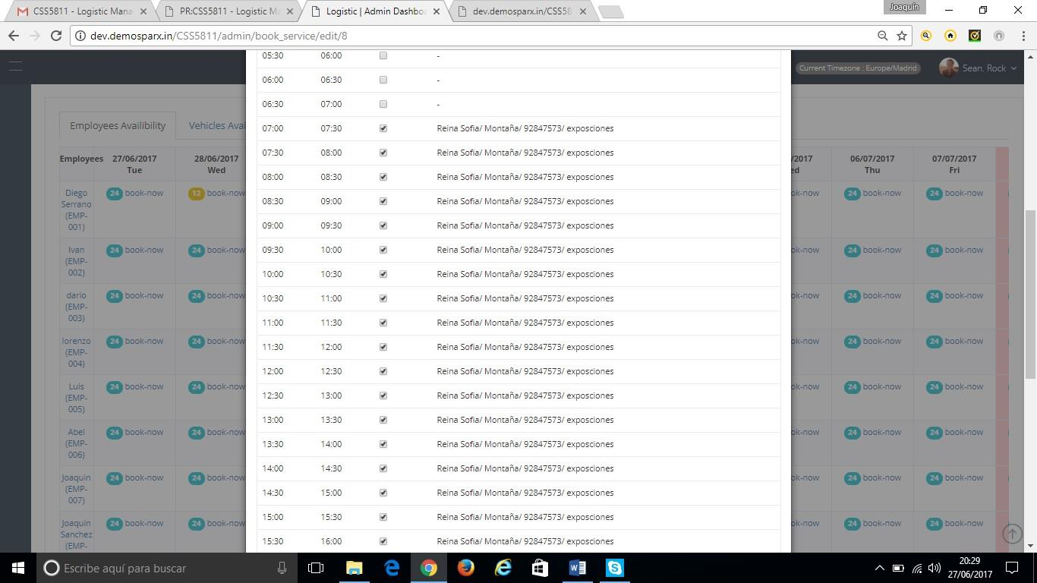

1. The customer wants it in hours not half hours (24 hours not 48 half hours).

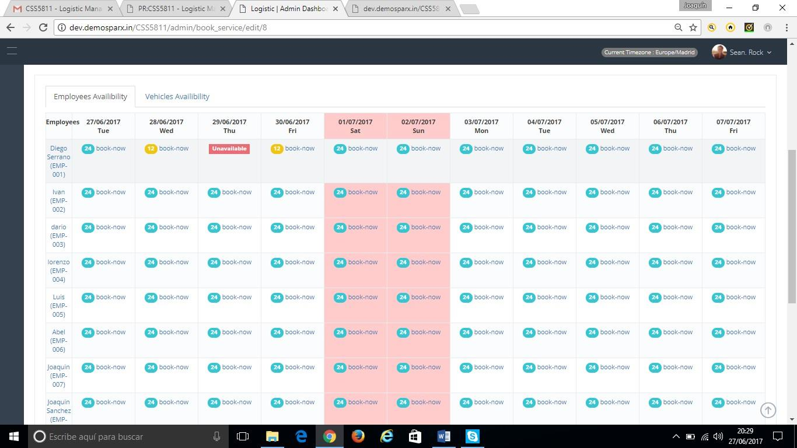

1. The day 28 I've selected more hours than the shows timing (3 extra hours). We need to show the number of hours.

2.- Whenever I press vehicles availability.

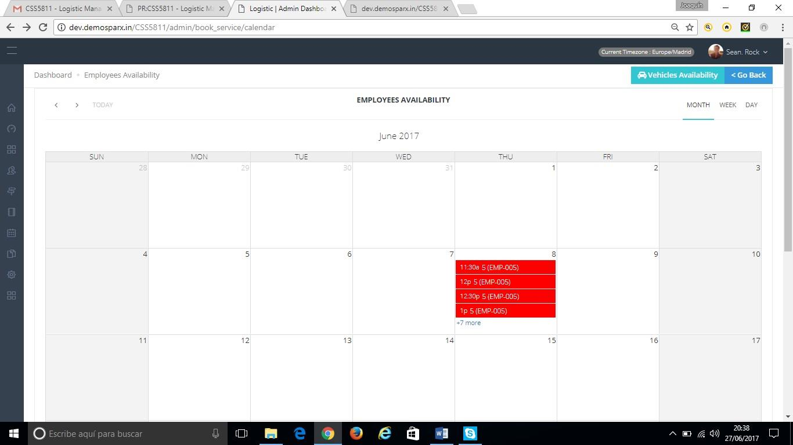

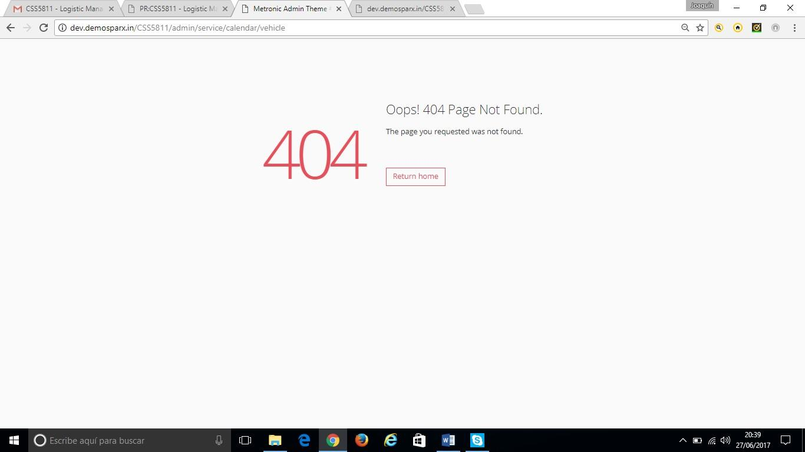

3- We don't understand this.

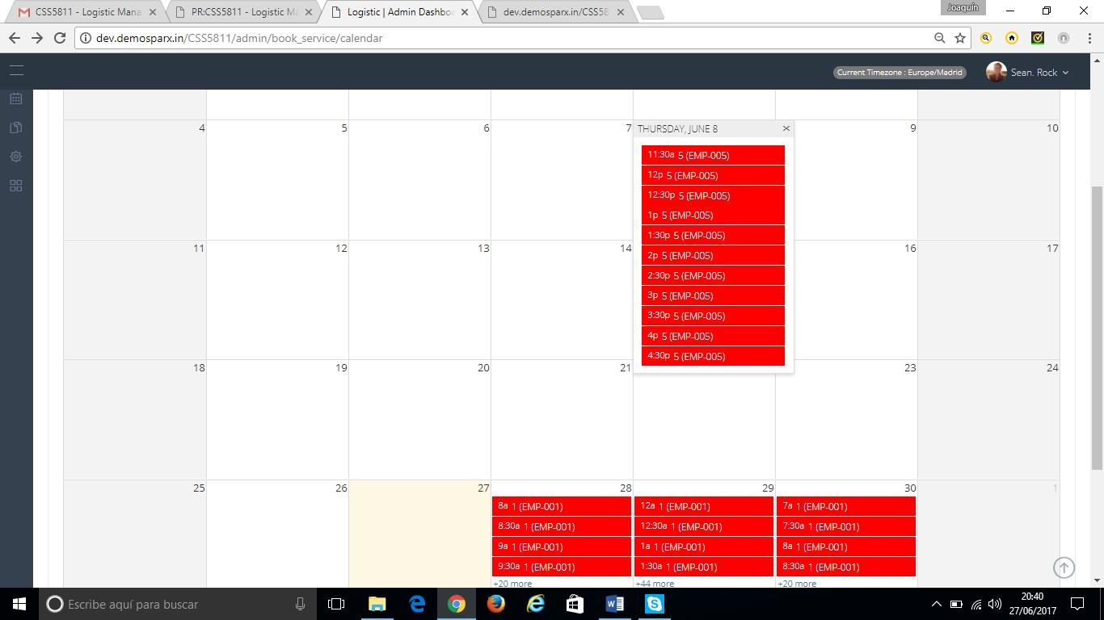

It's not possible to recognize any employee or vehicle and we need to be able to check the available and booked employees and vehicles.

We don't understand this design.

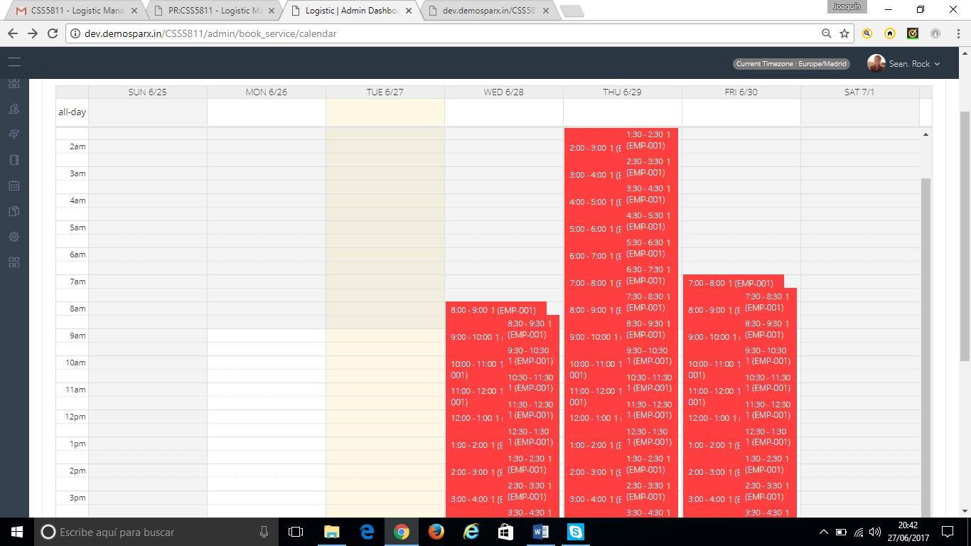

We need to show it clearer. We can list all the employees and vehicles and show the available in green and the unavailable in red every day.

4.-

a.- We need to put the name of the contract not the code. The manager is not going to be able to recognize codes in any part of the program or in any report.

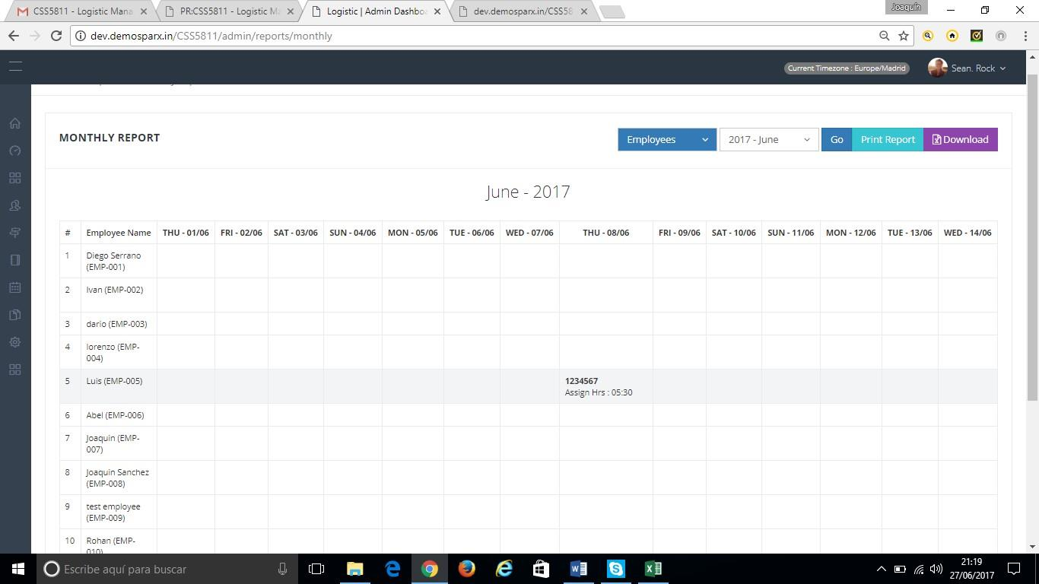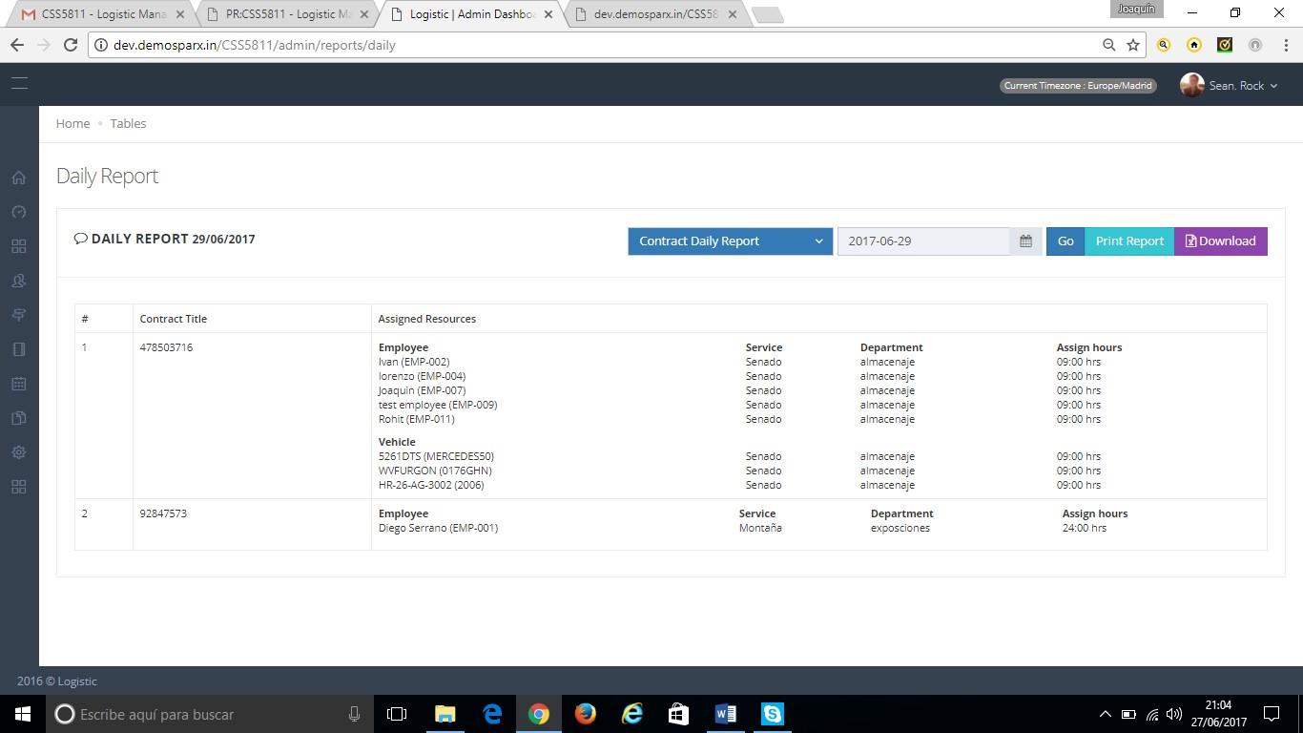



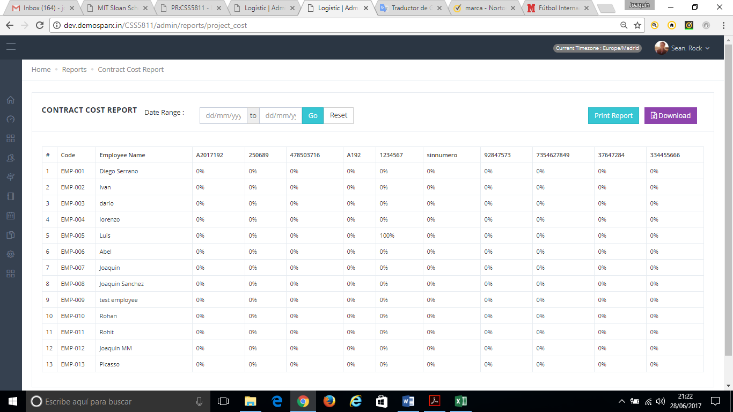

b.-Exporting PDF's is not working.

5.- Little points: It's not possible to see properly the Schedule/calendar selecting the leave days. It’s not possible to select the month

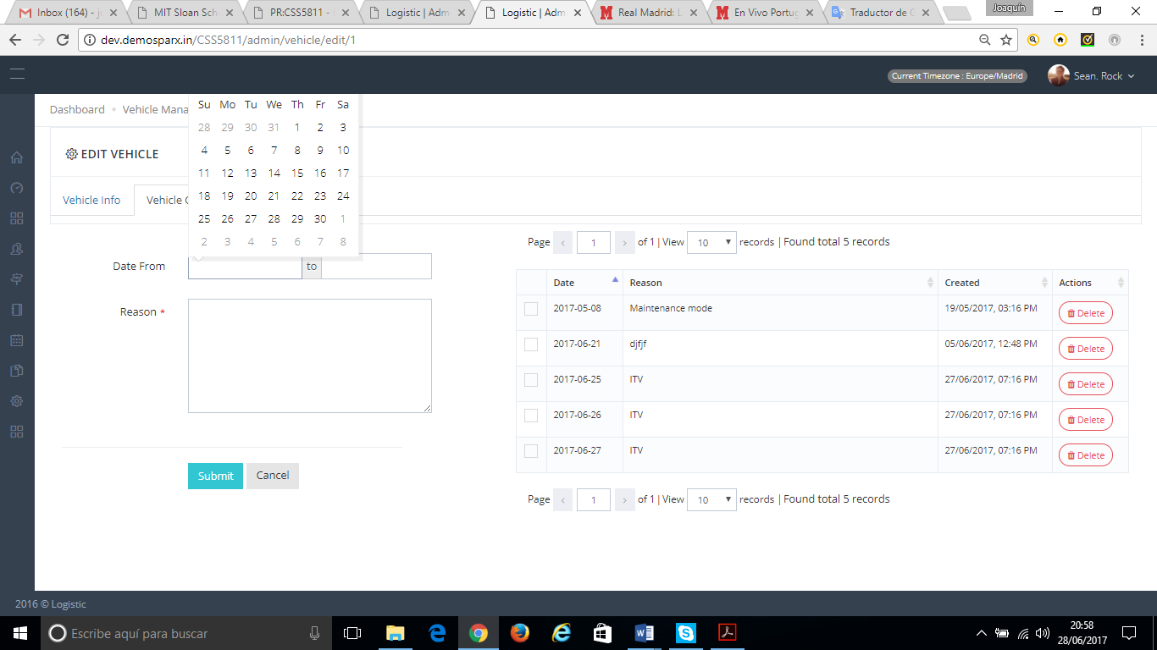

6.- In the book services: It's necessary to be able to modify any assignment or create a services in the past.

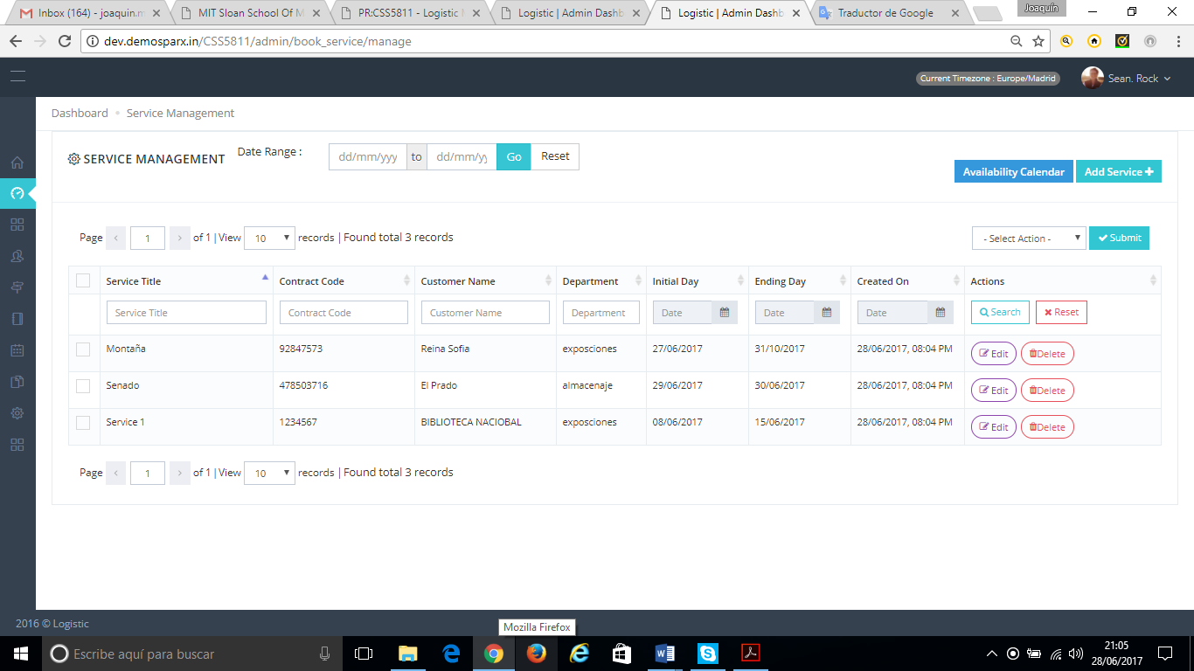

7.- DASHBROAD SCREEN

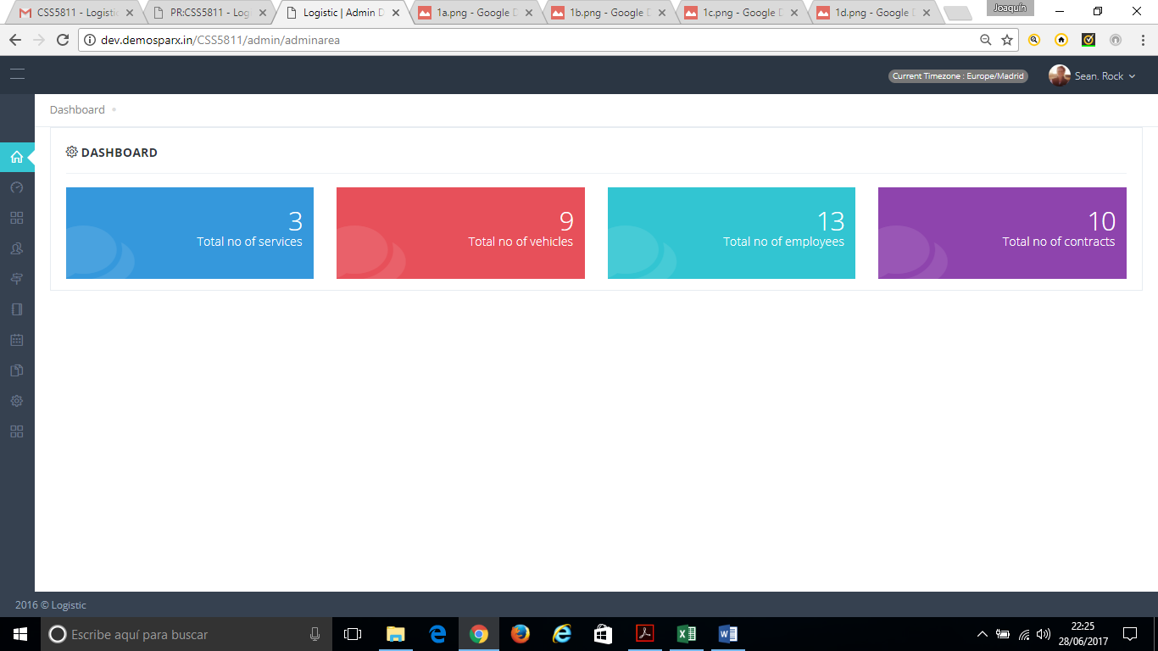

Here there is no interesting info. Please add here the daily report.

8.- We must **translate the program**

**Option 3**. Easiest way just translates some main buttons

Hard coded string for text **(12 hours)**/with module **(24 hours)**